

DAY21 ASSIGMENT

BHANU PRAKASH REDDY CHILUKURI



February 21, 2022

NB HEALTHCARE TECHNOLOGES

|  |
| --- |
| 1. Update your Visual Studio with .Net Framework Templates add on  (As discussed in the class) |

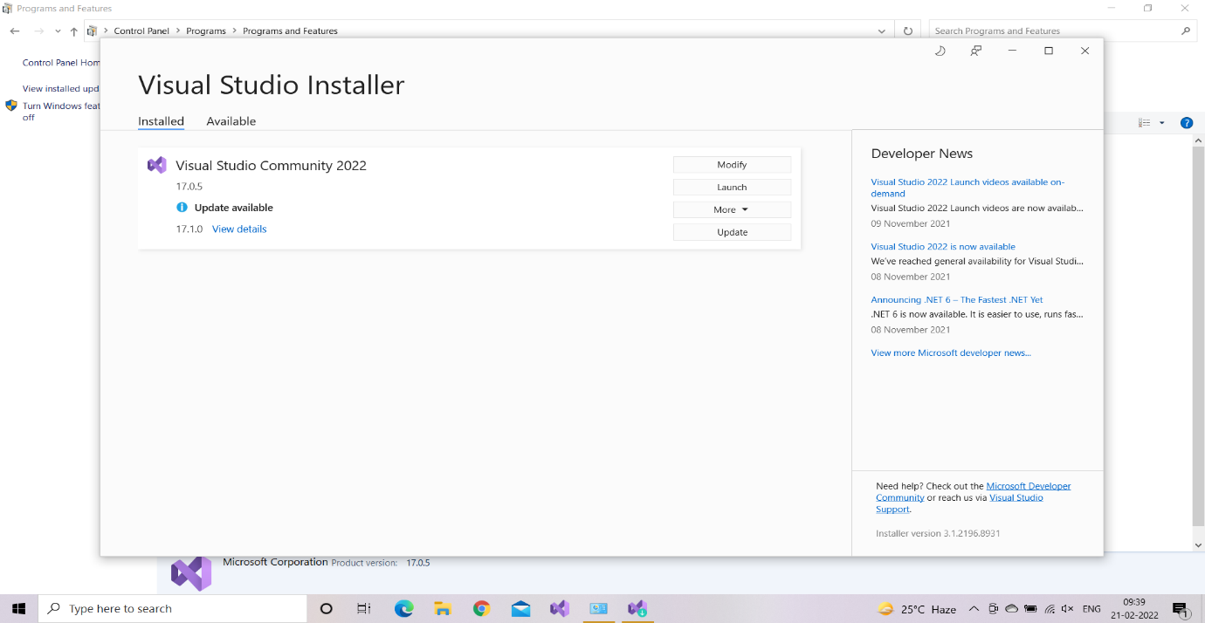

|  |
| --- |
| 2. Create a web service for Mathematical Operations.  Example: Factorial, add, mul, div. |

Code:

//Author: Bhanu Praksh Reddy

//Creating a webservice for mathematics operation

public class WebService1 : System.Web.Services.WebService

{

[WebMethod]

public int Factorial(int n)

{

int fact = 1;

for (int i=1;i<n; i++)

{

fact *= i;

}

return fact;

}

[WebMethod]

public int Add(int a,int b)

{

return a+b;

}

[WebMethod]

public int Mul(int a, int b)

{

return a * b;

}

[WebMethod]

public int Div(int a, int b)

{

return a / b;

}

}

Output:

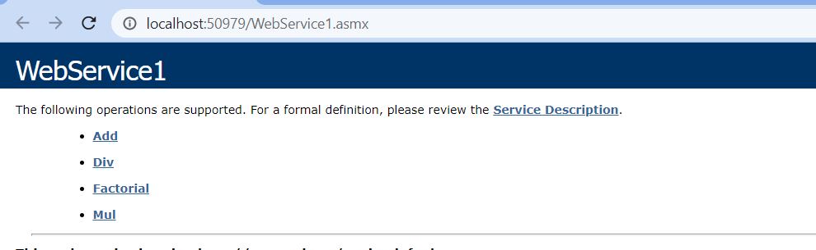

|  |
| --- |
| 3. Create a Console Application and consume the webservice. |

Code:

using ClientApp.ServiceReference1;

namespace ClientApp

{

internal class Program

{

static void Main(string[] args)

{

WebService1SoapClient obj=new WebService1SoapClient();

Console.WriteLine($"The factorial of the number is {obj.Factorial(4)}");

Console.WriteLine($"Sum of the numbers is {obj.Add(4,6)}");

Console.WriteLine($"Multiplication of the numbers is {obj.Mul(7,3)}");

Console.WriteLine($"Divison of the numbers is {obj.Div(30,10)}");

Console.ReadLine();

}

}

}

Output:

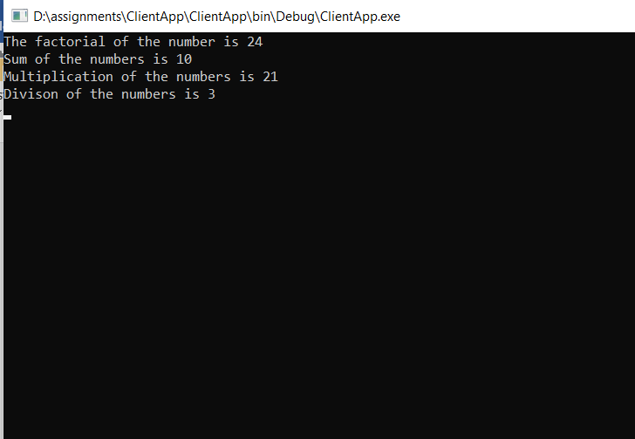

|  |
| --- |
| 4. Create a Windows Forms application and consume the webservice  [ for finding factorial of the number] |

Code:

private void button1_Click(object sender, EventArgs e)

{

int n = Convert.ToInt32(textBox1.Text);

WebService1SoapClient obj = new WebService1SoapClient();

textBox2.Text = obj.Factorial(n).ToString();

}

Output:

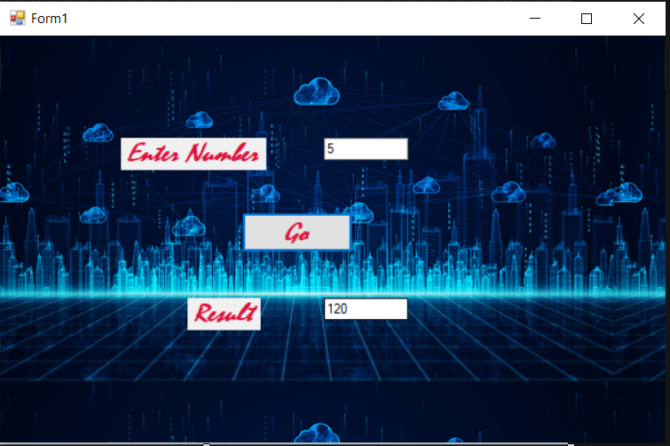

|  |
| --- |
| 5. Put the screen shots of webservice running. |

